Price’s Pony Express
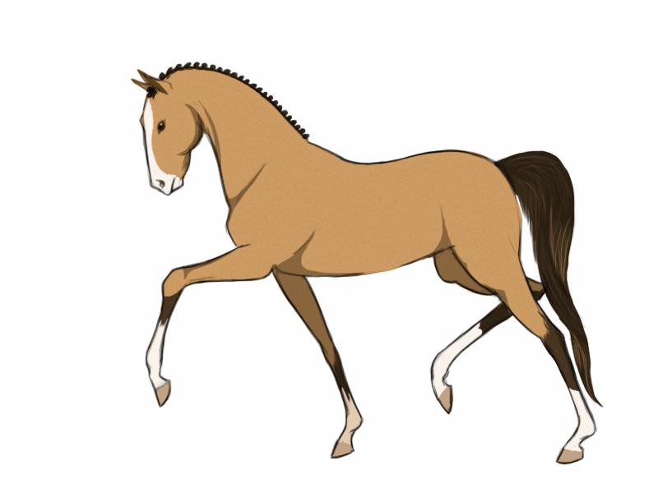09/28/15  hprice@paulding.k12.ga.us
  Reading : Round up at Rio Ranch will be completed. You will be reading about the season of fall. Some standards covered include asking and answering questions, describing problems and solutions,  Spelling: Quiz on October 2nd: spelling pattern long o and i.  Toe, slow, old, mind, by, follow, dry, load, row, sigh  Challenge: broken, carefully, cattle, gently, safety  Language Arts: Prefixes, formal and informal language, writing complete sentences.  Of special note. You all did wonderful work saving Fred in our latest experiment. I love to see junior engineers at work. Great problem solvers rock! | Specials :  Monday: Art  Tuesday: PE  Wednesday: Music  Thursday :PE  Friday: PE  Math: expanded notation, number names, word form, addition and subtraction in word problems, number strategies  Science: change of seasons  Social Studies: An introduction to the mayor, governor, and president and the jobs they do for us as citizens.  Homework Corner :  Homework is due Monday of the following week. Please continue to read for the reading log. You may receive extra homework in spelling as needed.  Dates to Remember:  10/2: PTA family movie night at dusk  Conference week is October 12th-16th. I may need to meet you on an alternative date due to a math conference that is out of town. If you need a particular day, please let me know so that I may accommodate you.

